Create a python folder: python3 -m venv folder_name

Active: source folder_name/bin/activate

Django install: pip install Django

Update :python3 -m pip install –upgrade pip

Django project make: Django-admin startproject project_name

If you need make a app this project name then you go cd this project = Django-admin startapp project_name

cd-

Run server: python3 manage.py runserver

1st viesws .py= from django.shortcuts import render,HttpResponse

def home(request):

return HttpResponse ("hi")

urls.py= path('home/',home,name="home"),

outpur= hi

function base viws(views.py) = def home(request):

return render(request,'home.html')

#classs make:

Now pass some vale in html

For ex: name [‘fahadk’,’dfdf’]

Make app in a project : python manage.py startapp app_name

After create app go to main project then Installed_app under write new app name

**New Course**

Cd – change Directory

Mkdir=folder create

Make pyton deractory: python3 -m venv env

Activete : source env/bin/activate

Dectivate: Dectivate

Now chack: pip3 list

Then chack :django-admin –version if dajango not install then install: pip3 install django

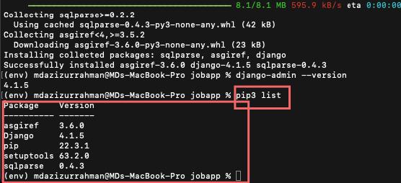

krjfid